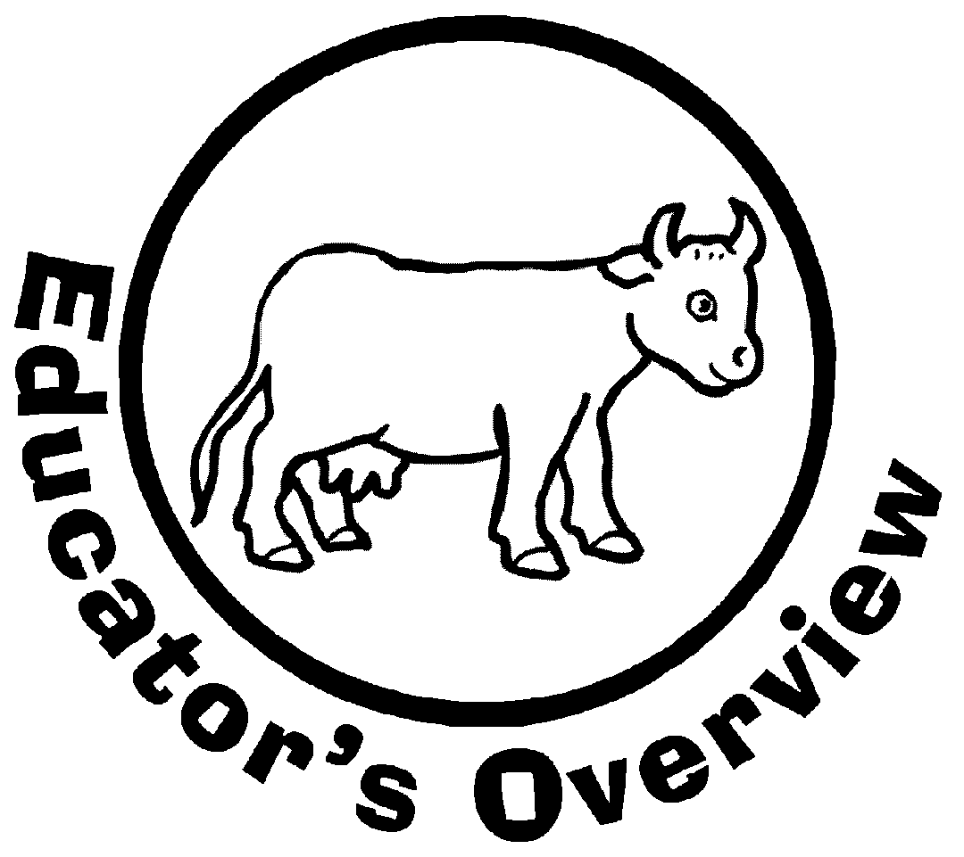
COOL COWS, DYNAMITE DAIRY

In this exhibit from our Animal Improvement Programs Laboratory, students will explore how cows have been bred to produce large volumes of one of our most important food sources: milk. Hands-on activities include discovering how dairy breeds differ (match game), how genes influence the way that a cow looks and produces (pedigree charts), how cows are taken care of on modern farms (milking machine demonstration), and how dairy products differ (“play food”).

Primary Take-Home Message
- Cows contribute to our everyday welfare because they produce a high-quality food at a reasonable price.
- The genes (DNA) that calves receive from their parents affect the way that they look and how many gallons of milk they can produce each day.
- Foods made from milk (dairy products) can look very different (cheese, butter, yogurt, ice cream).
- Milk and dairy products improve the quality of the American diet.

Ideas for In-Class Preparation
- Familiarize class with vocabulary words (attached).
- Familiarize class with dairy cattle breeds (teacher overview attached).
- Familiarize class with basics of genetic inheritance (teacher overview attached).
- Familiarize class with structure of modern dairy farm (teacher overview attached).
- Familiarize class with milk processing (teacher overview attached).
- Familiarize class with different kinds of dairy foods (teacher overview attached).
Over…
Ideas for Follow Up
- Virtual field trip (“The Story of Milk” – http://www.moomilk.com/tour.htm)
- Coloring page (attached)
- Word scramble (attached)
- Spelling quiz on vocabulary words
- In-class activity (“Make Butter” – http://webexhibits.org/butter/doityourself.html)
- AIPL Kid’s Corner (http://aipl.arsusda.gov/kc/kcindex.html)
COOL COWS, DYNAMITE DAIRY
Vocabulary

Barn – Building where farm animals, their food, and farm equipment are kept
Bovine – Anything related to cows
Breed – Group of animals that differ from related kinds of animals
Bulk tank – Refrigerated tank at the farm in which milk is cooled quickly and stored until picked up to be taken to the processing plant
Bull – Adult male of cattle
Butter – Solid, yellow, fatty food made by churning milk or cream
Calf (plural, calves) – Young bovine, can be either male or female
Cattle – Bovine animals kept on a farm; refers to more than one animal and can be either male or female
Cheese – Food made from milk usually by removing the whey and molding or flavoring the remaining curd
Cow - Adult female of cattle
Cream – Yellowish part of milk that has the fat
Curd – Solid part of milk after it has soured and thickened
Dairy – Anything related to animals raised to produce milk and foods made from milk
Feed – Food for farm animals, usually a mixture
Fodder – Coarse, dry food for farm animals
Forage – Food (pasture) for grazing animals
Gene – DNA that controls or influences how a bodily trait or activity (such as coat color, height, milk yield) is inherited
Genetics – Branch of biology that deals with inherited traits and how they are different
Grain – Seeds or kernels from various cereal plants (such as wheat, oats, and corn); an important food for farm animals
Graze – To feed on growing forage
Over…
Heifer – Young cow; especially one that has not had a calf
Herd – Group of cows that live together
Heredity – Passing of genes and genetic traits from parent to offspring
Homogenization – Pressurization of milk so that the fat does not separate out
Horn – Hard, boney growth on the head of cattle (usually in pairs)
Ice cream – Frozen dairy food that has sweetened and flavored cream
Lactation – Process of giving milk
Livestock – Farm animals
Low-fat milk – Milk that has part of the fat removed (also called reduced-fat milk)
Milk – Whitish liquid made by female mammals as food for their young
Milker – Person who milks cows
Milking machine – Machine that takes milk out of the cow’s udder
Milking parlor – Building where dairy cows are brought specifically to be milked
Pasture – Land used for grazing
Pasteurization – Heating milk to a high temperature to kill disease-causing bacteria
Pedigree – Chart or list that shows the line of ancestors (such as parents or grandparents)
Polled – Having no horns
Raw milk – Milk as it comes from the cow before processing
Silage – Fodder (such as hay or corn) that is broken down without air (usually in a silo) to make rich moist food for farm animals
Silo – Trench, pit, or especially a tall cylinder used for making and storing silage
Skim milk – Milk from which the fat has been removed
Teat – Part of the udder through which milk is drawn
Trait – Quality or characteristic that differs
Whey – Watery part of milk after it has soured and thickened
Yogurt – Partially solid milk that has been soured by bacteria

COOL COWS, DYNAMITE DAIRY
6 Major Breeds of U.S. Dairy Cattle

Holstein (93%): The Holstein breed began in Holland (Netherlands) and was brought to the United States in 1852. Holsteins are large cows with spotted patterns of black-and-white or red-and-white. A Holstein calf weighs about 90 pounds at birth, and an adult Holstein cow weighs about 1,500 pounds. Holsteins give the most milk per cow of all breeds (an average of 61 pounds or 7½ gallons per day). One top producing Holstein cow averaged over 24 gallons of milk per day. The milk is 3.6% fat and 3.0% protein. Holsteins are the most popular dairy breed in the United States, and 9 of every 10 U.S. dairy farmers currently milk Holsteins.

Jersey (5%): This breed started on the Isle of Jersey, a small island in the English Channel, and was brought to the United States during the 1850s. Jerseys are the smallest dairy cows. Calves weigh about 60 pounds at birth, and adult cows weigh approximately 900 pounds. The coat color is brown that can vary from very light beige (fawn) to almost black. Some Jerseys have white markings or spots. Both bulls and cows are usually darker around the hips, head, and shoulders. Daily milk yield for an average Jersey cow is 44 pounds (5¼ gallons). Because the milk is high in fat (4.6%) and protein (3.6%), it is preferred for making cheese and butter.

Brown Swiss (1%): The Brown Swiss breed began in Switzerland and is thought to be the oldest of the dairy breeds. Brown Swiss cows were brought to the United States in 1869. Brown Swiss are large cows, about the same size as Holsteins. The color of Brown Swiss varies from light brown to gray. Some calves are born almost white and later change to their adult color. Brown Swiss cattle are noted for their strong feet and legs, long lives, and quiet temperament. The gestation length (time that the cow is pregnant) is 9 months and 16 days, which is 10 days longer than for other dairy breeds. Daily milk yield per cow averages 49 pounds (5¾ gallons). Milk from Brown Swiss cows has moderate fat (4.0%) and high protein (3.4%) content and also is valued for making cheese.

Over…
Guernsey (<1%): The Guernsey breed started on the Isle of Guernsey, another island in the English Channel, around 960 A.D. and was brought to the United States around 1840. Guernsey cows are medium-sized (about 1,200 pounds) and have brown-and white spots. The brown color can be light golden brown to nearly mahogany. Daily milk yield per cow averages 41 pounds (5 gallons) with 4.5% fat and 3.4% protein. The milk often is referred to as “the golden product” because of its yellow butterfat content.

Ayrshire (<1%): This breed started in the county of Ayr in Scotland and was brought to the United States around 1832. Ayrshires are medium-sized (adult cows weigh about 1,200 pounds) with red-and-white spots. The red color varies from light mahogany to nearly black. The spots are usually jagged and small, sometimes even speckled. Daily milk yield of Ayrshire cows averages 43 pounds (5¼ gallons) with 3.8% fat and 3.2% protein. Ayrshire cattle are noted for their hardiness and excellent foraging ability. Most Ayrshires in the United States can be found in the colder climates of the Northeast and Midwest states.

Milking Shorthorn (<1%): One of the oldest recognized breeds in the world, Shorthorn cattle originated in northeastern England and were brought to the United States in 1783. Shorthorns provided milk, meat, and transportation for many American pioneers. The Milking Shorthorn is not a separate and distinct breed but a segment of the Shorthorn breed, which also includes Beef Shorthorns. Milking Shorthorns are medium-sized (adult cows weigh about 1300 pounds) and either a shade of red, white, red-and-white spots, or roan (a mixture of red and white hairs). These docile cows average 39 pounds (4¾ gallons) of milk daily with 3.6% fat and 3.1% protein and are large enough to have considerable beef value when their long productive lives end.

COOL COWS, DYNAMITE DAIRY
Understanding Genetics

Heredity: An animal (or a person) often looks a lot like one or both of its parents because of the genes (DNA) that are passed along from the father and mother to the animal. For example, kittens grow up to look like cats, and calves grow up to look like cattle. Genes influence how all the traits of an animal are expressed, sometimes directly and strongly (for example, coat and eye color, height, or weight) … and other times indirectly or in combination with other genes (for example, how much milk a cow produces, the composition of the milk, or how well the cow resists disease). Because traits are influenced by genes, the appearance or behavior of animals can be changed by choosing animals with the features you consider most desirable to be parents of the next generation of animals. Genetic change is permanent and adds up over time.

GENETIC INHERITANCE – Why does a cow look (or not look) like its parents?

Gene expression: Genes work in pairs. Sometimes each gene has an equal influence on how a trait is expressed, but many times one gene is dominant over the other (recessive) gene in determining the trait. For example, whether or not a cow has horns is controlled by a dominant-recessive pair of genes. The gene for no horns (polled) is dominant, and the gene for horns is recessive. A cow with 2 “polled” genes will have no horns. A cow with 2 “horned” genes will have horns. A cow with 1 polled gene and 1 horned gene will not have horns because the horned gene is recessive and the polled gene is dominant.

Genetic evaluations: Differences between individual animals that can be passed on to future generations (inherited) can be measured through genetic evaluation. How a calf will look or produce can be estimated (scientifically guessed) by looking at an animal’s pedigree (ancestor chart) to see how its ancestors looked or produced, When the calf grows up, its own appearance and ability to give milk can be used to provide more information on how its genetics can be passed to its calves. Genetic evaluations are important for choosing parents with superior genes for traits of interest (such as milk production or long life).
COOL COWS, DYNAMITE DAIRY
Today’s Dairy Farm

Housing: Many of today’s modern dairy farms use “free stall housing,” which is a type of barn that allows cows to eat and sleep whenever and wherever they choose. Dairy cows always have access to feed and fresh, clean water. Farmers ensure that their cows have room to lie down, stretch, eat, and drink comfortably. Many dairy farmers have installed rubber or other non-slip flooring in their barns to make it easier for the cows to move around. Cows may sleep on waterbeds, sand beds or mattresses made of rubber, foam or a combination of the two. Most dairy barns use advanced ventilation systems to assure healthy air quality. On warm days, farmers use fans and misters to make cows feel cool and comfortable.

Feed: Farmers use professional nutritionists to develop a scientifically nutritious diet for their cows. This diet is called a total mixed ration and includes hay (such as alfalfa and timothy), silage, grains (such as wheat, oats, and corn), protein sources (such as soy) and other vitamins, minerals, and fats. Cows eat from 40 to 80 pounds of food a day and are fed up to 8 times a day. Electrically operated feeders and mixer wagons make feeding quicker and easier. Cows drink 30 to 40 gallons (about a bathtub full) of water each day. A cow must drink 2 gallons of water for every gallon of milk that she gives.

Milking: Before milking machines were invented in 1894, farmers could only milk about 6 cows per hour. Today farmers use machines that work on vacuum pressure to milk more than 100 cows per hour. Cows usually are milked by machine 2 or 3 times each day. The building where cows are milked is called a milking parlor. After a cow enters the parlor, her udder is washed to keep the milk clean and to signal the cow to “let down” her milk. A milking machine with 4 teat cups is attached to the cow, and the milk is cooled and pumped into a large storage tank (bulk tank).

COOL COWS, DYNAMITE DAIRY
Milk Processing — From Farm to Store

History: In 1841, the first regular railway shipment of milk was started from Orange County, NY, to New York City. Milk condensing and pasteurization (process of heating milk to a high temperature to kill bacteria) were invented in 1856 to combat food poisoning and other illnesses related to lack of refrigeration and preservation techniques. Refrigeration became available in the 1880s. Homogenized milk premiered successfully in 1919; homogenization is the process of pressurizing milk so that the fat does not separate out. Today milk gets from the cow to the store in about 2 days.

On the farm: Raw milk is cooled to 38˚F and is stored in refrigerated storage tanks. A tanker truck comes to pick up the milk daily and take it to the processing plant. The truck driver tests the milk before pumping it into the truck to make sure that it's safe to drink. Each truck is insulated and acts like a giant thermos bottle to keep the milk cool until it reaches the processing plant.

At the processing plant: Raw milk is checked again at the plant to make sure that it’s safe to drink and then pumped from the milk truck into a storage tank. Then the milk is homogenized and pasteurized. Milk also is fortified with vitamin D (and vitamin A for lowfat and skim milk) to make it even more healthful. Dairy processing plants make different types of milk, ice cream, cheese, yogurt, butter, and other dairy products.

At the store: At the grocery store, milk is kept refrigerated at 40˚F or lower. When kept refrigerated at that temperature, milk should last approximately 7 days past the sell-by date on the container. A 5°F increase in storage temperature shortens milk’s shelf life by 50%.
COOL COWS, DYNAMITE DAIRY
Dairy Foods — Milk, Butter, Cheese,
Yogurt, Ice Cream

Milk: Whole milk is about 87% water, 5% lactose (milk sugar), and 8% protein, fat, vitamins, minerals. A gallon of milk weighs a little more than 8½ pounds. Each serving of milk provides 10% or more of the recommended daily intake for calcium, vitamin D (if fortified), protein, potassium, vitamin A, vitamin B12, riboflavin. and phosphorus. The average American drinks about 22 gallons of milk each year, and 99% of all U.S. households buy milk. Fluid milk sales account for 32% of total U.S. milk consumption. Low-fat milk is about 2/3 of total milk consumption. Nonfat dry milk accounts for 4% of the milk consumed in the United States. It takes 7 pounds (a little more than 3 quarts) of fluid milk to make 1 pound of nonfat dry milk. California is the top milk-producing State.

Butter: Butter is made from milk, cream, or both (with or without common salt) and contains at least 80% fat. Fresh cream is churned until the fats separate from the liquid (buttermilk). Americans consume more than 4 pounds of butter per person per year. Butter accounts for 13% of U.S. milk consumption. Making 1 pound of butter takes 21 pounds (almost 2½ gallons) of whole milk. California is the top butter-producing State.

Cheese: All cheese is made from milk, but different manufacturing and aging
processes are used to produce different kinds of cheeses. Cheese is made by curdling milk, stirring and heating the curd, draining off the whey (the watery part of milk), collecting and pressing the curd, and in some cases, ripening. About 1/3 of all milk produced each year in the United States is used to make cheese. Making 1 pound of cheddar cheese takes 10 pounds (almost 5 quarts) of milk. The most commonly produced cheeses in the United States are cheddar (34%), mozzarella (33%), and American (8%). Wisconsin is the top cheese-producing State.

Over…
Yogurt: Yogurt is a mixture of milk and cream fermented by bacteria. Sometimes sweeteners (sugar, honey, aspartame), flavorings (vanilla, coffee), and other ingredients (fruits, nuts, jams) may be added to yogurt. Making 8 ounces of yogurt (1 cup) takes 1 pound (about 1 pint) of milk. California is the top yogurt-producing State.

Ice Cream/Frozen Yogurt: Historians estimate that ice cream evolved sometime during the 16th century in Italy, perhaps from a recipe Marco Polo brought from the Orient. The hand-crank freezer, which was patented in 1846, led to the establishment of the first commercial ice cream plant in Baltimore in 1851. Ice cream is made by stirring (while freezing) a mix of milk (or cream), sweeteners, and flavorings. It takes 13 pounds (1½ gallons) of milk to make ½ gallon of ice cream. Frozen products account for 7% of U.S. dairy consumption. Frozen yogurt was introduced in the late 1960s and is made like ice cream but with the addition of bacteria that are used to make yogurt. The average American eats about 5½ gallons of ice cream each year, and 93% of U.S. households eat ice cream. California is the top ice cream-producing State.

COOL COWS, DYNAMITE DAIRY
Dairy Breeds Coloring Page
Color each cow the correct color for the breed name under the cow. Add spots if needed.

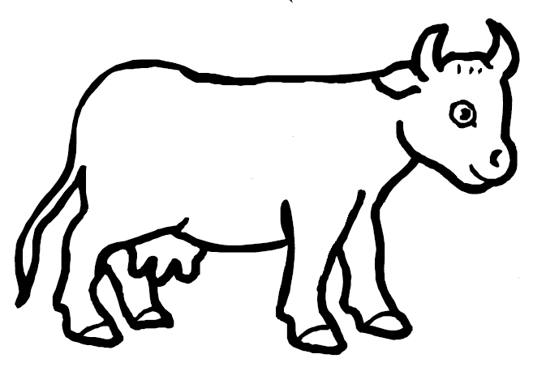

Holstein

Brown Swiss

Ayrshire

Jersey

Guernsey

Milking Shorthorn

COOL COWS, DYNAMITE DAIRY
Super Scramble
Try a few … or do them all! They’re all about cows and dairy products.

ydira
deber
curd
zagre
ratti
gilsea
wsoc
sonhr
gotruy
taclet
oils
yhew
rehfie
narb
tubtre
macer
fegaor
owl-aft ilmk
dityrehe
zestiarunopiat
edrh
kinglim nichame
cie rcmea
reddof
lfac
esehce
setenicg
gomohenniozati
saperut
lubls
stockevil
giran

COOL COWS, DYNAMITE DAIRY
Super Scramble ANSWERS

ydira … DAIRY
deber … BREED
durc … CURD
zagre … GRAZE
ratti … TRAIT
gilsea … SILAGE
wsoc … COWS
sonhr … HORNS
gotruy … YOGURT
taclet … CATTLE
oils … SILO
yhew … WHEY
rehfie … HEIFER
narb … BARN
tubtre … BUTTER
macer … CREAM
fegaor … FORAGE
owl-aft ilmk … LOW-FAT MILK
dityrehe … HEREDITY
zestiarunopiat … PASTEURIZATION
edrh … HERD
kinglim nichame … MILKING MACHINE
cie rcmea … ICE CREAM
reddof … FODDER
lfac … CALF
esehce … CHEESE
setenicg … GENETICS
gomohenniozati … HOMOGENIZATION
saperut … PASTURE
lubls … BULLS
stockevil … LIVESTOCK
giran … GRAIN

